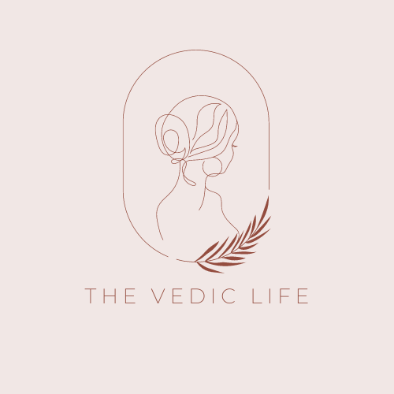

Dear Student,
It gives me immense pleasure to welcome you to the Ayurveda Lifestyle Coach Training Program for the year 2023. I am excited to assist you in your journey to enhance your knowledge and experience of Ayurvedic Health Care.
Please find attached a learning agreement. Please reach out to me if you have any questions or concerns.
Below are the steps that you need to take next:
- Please go through the learning agreement and sign it. You are required to return the signed agreement by April 8th.
- The classes will commence on Sunday, April 9th, at 6:00 pm IST via Zoom, and you will receive the link before the class.
- Begin journaling about your expectations and vision for your Ayurveda learning experience. Please consider questions such as what challenges you anticipate, how you plan to make the most of the learning experience, and what outcome you hope to achieve.

Learning Agreement

The learning agreement has been provided to establish a mutual understanding of the expectations of the course. Kindly read and agree to the following:
- I acknowledge that the Ayurveda Lifestyle Coach Training by The Vedic Life is a course focused on prevention and healthy lifestyle, and it is not a substitute for allopathic medicine. I agree to first consult a qualified ayurvedic or allopathic doctor regarding any herbs or diet that I may include in my health routine.
- I will utilise the knowledge gained from the Ayurveda Lifestyle Coach Training to the best of my ability. I understand that my instructors cannot be held responsible for any health issues that may arise for myself or my clients.
- I shall attend as many live classes as possible, as the experience is greatly enhanced by everyone’s regular presence, and the learning process is shaped by everyone's consciousness. If I am unable to attend a class due to illness or family events, I will notify the instructor. It is advisable to log in 15 minutes early to meditate or review learning material and prepare oneself for learning.
- To receive a certificate of completion, I am required to attend 80% of the live classes.
- I understand that the Ayurveda Lifestyle Coach Training will provide me with foundational knowledge to educate the public on Ayurvedic diet, healthy lifestyle, and herbal supplements. I acknowledge that I cannot diagnose disease or treat illness unless I am a licensed medical professional. This course focuses on prevention and general imbalances related to mind-body types. It is important to note that this is NOT an Ayurvedic course to become an ayurvedic doctor, but only to assist yourself and others in lifestyle recommendations to prevent disease and pacify imbalances in the body.
- The materials and video recordings are not to be shared without explicit permission from the course organizers or instructor.
- Please be aware that every country has specific laws related to the practice of Ayurveda.
- I understand that the curriculum taught in this course has not been approved by NAMA (National Ayurveda Medical Association).
- I will maintain confidentiality of my peers in any sharing their personal health related matters.

Date: ________________________________
Signature: ____________________________
Full Name: ____________________________

